USB2.0实验指导

实验目的
- 了解在UP-CUP S2440平台上实现非接触式IC卡驱动程序的基本原理
- 了解Linux驱动开发的基本过程

实验环境
- 硬件：UP-CUP S2440嵌入式实验仪，PC机pentumn500以上, 硬盘40G以上,内存大于128M，USB2.0扩展模块
- 软件：Vmware Workstation +fedora8 + MiniCom/Xshell + ARM-LINUX交叉编译开发环境

实验步骤
- 实验目录：USB2.0
- 内核配置
由于USB2.0模块与高精度AD扩展模块在内核配置方便有冲突,因此需要重新配置内核文件,以下是内核配置步骤 (为方便使用,我们在/UP-CUP2440/SRC/exp/module/usb2.0/usb2.0/目录中已提供现成的内核镜像uImage，可直接将其下载到开发板中，也可按照下面的步骤重新编译内核)
- 修改底层驱动配置
[root@localhost /]# cd /UP-CUP2440/SRC/exp/kernel/linux-2.6.24.4/
[root@localhost linux-2.6.24.4]# vi arch/arm/mach-s3c2440/mach-smdk2440.c
注释掉168-186行内容
/*static struct resource s3c_ad7655_resource[] = {
[0] = {
.start = 0x18000000,
.end = 0x18000000 + 40,
.flags = IORESOURCE_MEM,
},
[1] = {
.start = IRQ_EINT0,
.end = IRQ_EINT0,
.flags = IORESOURCE_IRQ| IORESOURCE_IRQ_HIGHEDGE,
},
};

struct platform_device s3c_device_ad7655 = {
.name = "ad7655",
.id = -1,
.num_resources = ARRAY_SIZE(s3c_ad7655_resource),
.resource = s3c_ad7655_resource,
};
*/
添加&s3c_device_export_usb,注释&s3c_device_ad7655
static struct platform_device *smdk2440_devices[] __initdata = {
&s3c_device_usb,
&s3c_device_export_usb,
&s3c_device_lcd,
&s3c_device_wdt,
&s3c_device_dm9ks,
&s3c_device_usbgadget,
&s3c_device_i2c,
// &s3c_device_ad7655,
&s3c_device_sdi,
&s3c_device_ts,
&s3c_device_iis,
&s3c_device_rtc,
&s3c_device_ds,
&s3c_device_gpio,
&s3c_device_spi0,
};
- 配置内核
[root@localhost linux-2.6.24.4]# make menuconfig
进入Device Drivers目录
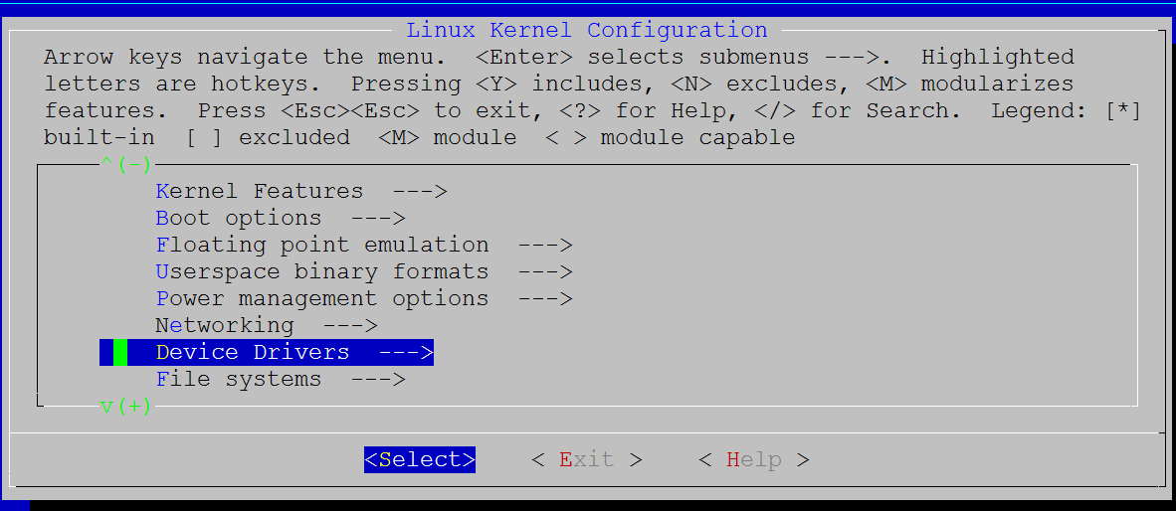
进入Character device目录
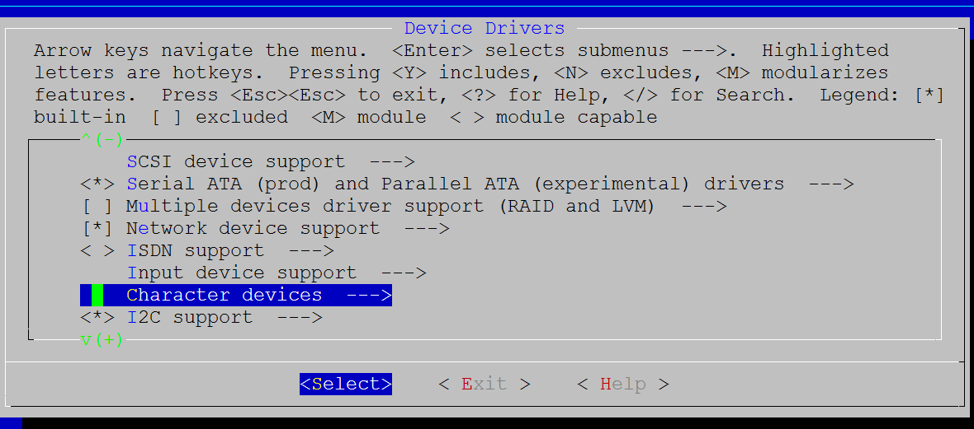
取消对ad7655的选择
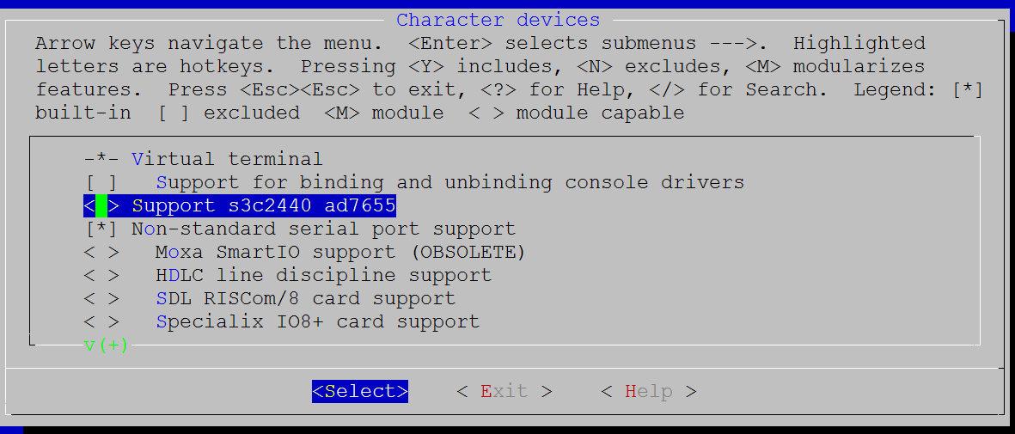
选择<*>USB Support→
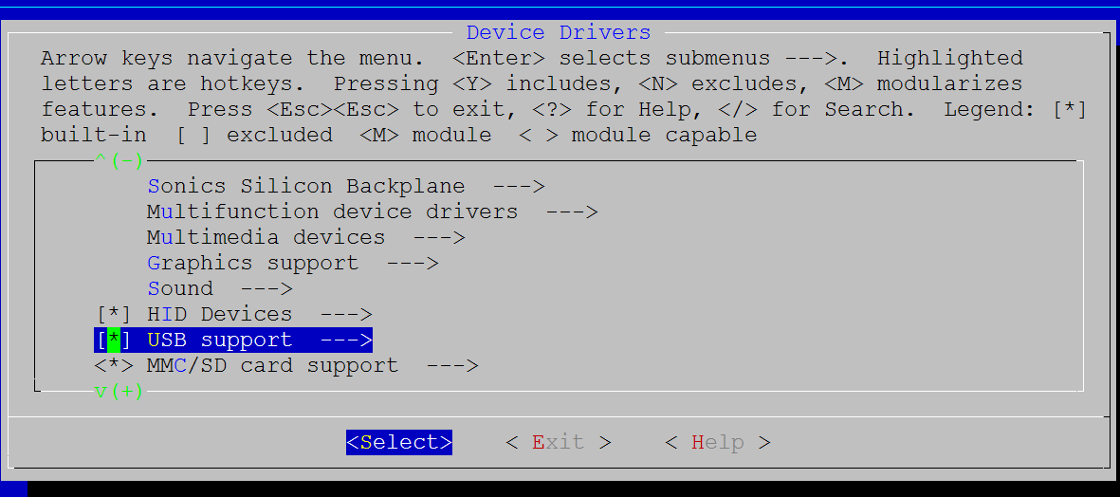
选择<M>ISP116X HCD support
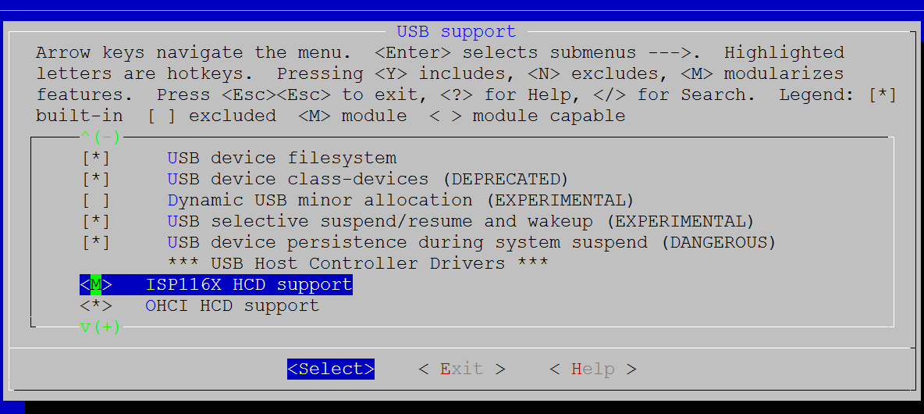
- 编译内核
[root@localhost linux-2.6.24.4]# make
[root@localhost linux-2.6.24.4]# ./make_uImage
将生成的uImage下载到开发板,具体操作方法可参考烧写手册,此处不再赘述。
- NFS挂载实验目录测试
1、将USB2.0扩展模块插入扩展插槽。启动UP-CUP2440实验系统，连好网线、串口线。通过串口终端挂载宿主机实验目录。
up-tech:~ # mount -t nfs -o nolock，rsize=4096,wsize=4096 192.168.1.145:/UP-CUP2440 /mnt/nfs/
2、进入串口终端的NFS共享实验目录。
up-tech:~ # cd /mnt/nfs/SRC/exp/module/usb2.0/usb2.0
up-tech: /mnt/nfs/SRC/exp/module/usb2.0/usb2.0 #insmod isp116x-hcd.ko
[116x: driver isp116x-hcd, 03 Nov 2005
<6>isp116x-hcd isp116x-hcd: ISP116x Host Controller
isp116x-hcd isp116x-hcd: new USB bus registered, assigned bus number 2
isp116x-hcd isp116x-hcd: irq 16, io base 0x18000002
board->sel15Kres is 0x1
value :0x1c09
HCHWCFG :0x28
HCHWCFG :0x1c09
HCRHDESCA :0x19001202
HCRHDESCB :0x0
HCRHSTATUS :0x0
HCRHPORTISTATUS1 :0x100
HCRHPORTISTATUS2 :0x100
HCRHPORTISTATUS1 :0x100
HCRHPORTISTATUS2 :0x100
the USB device you want to use needs 0 MA
the power of the USB interface avaliable is 0 MA
usb usb2: configuration #1 chosen from 1 choice
hub 2-0:1.0: USB hub found
hub 2-0:1.0: 2 ports detected
usb usb2: Product: ISP116x Host Controller
usb usb2: Manufacturer: Linux 2.6.24.4 isp116x-hcd
usb usb2: SerialNumber: isp116x-hcd
将U盘插入USB接口,会打印如下语句
up-tech:/mnt/nfs/SRC/exp/module/usb2.0/usb2.0 # usb 2-1: new full speed USB device using isp116x-hcd and address 2
the USB device you want to use needs 50 MA
the power of the USB interface avaliable is 500 MA
usb 2-1: configuration #1 chosen from 1 choice
scsi3 : SCSI emulation for USB Mass Storage devices
usb 2-1: Product: DataTraveler 2.00000000437
usb 2-1: Manufacturer: Kingston
usb 2-1: SerialNumber: 0000000437
scsi 3:0:0:0: Direct-Access Kingston DataTraveler 2.0 1.00 PQ: 0 ANSI: 2
sd 3:0:0:0: [sda] 984576 512-byte hardware sectors (504 MB)
sd 3:0:0:0: [sda] Write Protect is off
sd 3:0:0:0: [sda] Assuming drive cache: write through
sd 3:0:0:0: [sda] 984576 512-byte hardware sectors (504 MB)
sd 3:0:0:0: [sda] Write Protect is off
sd 3:0:0:0: [sda] Assuming drive cache: write through
sda:<7>usb-storage: queuecommand called
sda4
sd 3:0:0:0: [sda] Attached SCSI removable disk
sd 3:0:0:0: Attached scsi generic sg0 type 0

up-tech:/mnt/nfs/SRC/exp/module/usb2.0/usb2.0 # usb 2-2: new full speed USB device using isp116x-hcd and address 3
the USB device you want to use needs 50 MA
the power of the USB interface avaliable is 500 MA
usb 2-2: configuration #1 chosen from 1 choice
scsi4 : SCSI emulation for USB Mass Storage devices
usb 2-2: Product: DataTraveler 2.00000000437
usb 2-2: Manufacturer: Kingston
usb 2-2: SerialNumber: 0000000437
scsi 4:0:0:0: Direct-Access Kingston DataTraveler 2.0 1.00 PQ: 0 ANSI: 2
sd 4:0:0:0: [sda] 984576 512-byte hardware sectors (504 MB)
sd 4:0:0:0: [sda] Write Protect is off
sd 4:0:0:0: [sda] Assuming drive cache: write through
sd 4:0:0:0: [sda] 984576 512-byte hardware sectors (504 MB)
sd 4:0:0:0: [sda] Write Protect is off
sd 4:0:0:0: [sda] Assuming drive cache: write through
sda:<7>usb-storage: queuecommand called
sda4
sd 4:0:0:0: [sda] Attached SCSI removable disk
sd 4:0:0:0: Attached scsi generic sg0 type 0

